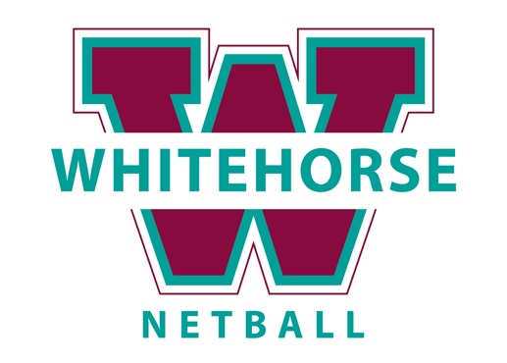
FAST FIVE TOURNAMENT ENTRY

- There will be two ten-minute halves with a 2-minute half time and a 3-minute change over in between games.
- Players may only represent one team.
- Teams can consist of all girls, but they will potentially play against mixed teams. Mixed teams can have a maximum of 3 males on the court at any one time.
- If there is more than one male on the court at the same time they must be in different sections of the court. For example, they cannot be C, GD and GK, but they could be C, GS and GK.
- All teams must provide their own scorer.
- Scorecards must be returned to mission control after each game.
- All teams must provide their own bibs. If you want rolling substitutions then two sets of bibs will be required but they must be the same or very similar colours (let us know if you cannot provide your own, we can try to assist you).
- Uniforms must be cohesive. For example, all black shorts/leggings with all grey shirts. Can wear netball dresses.
All normal netball rules apply however:
- Five players are to take the court – GS, GA, C, GD and GK.
- A team can still take the court if there are 4 players on court (one being the C).
- One point is scored if the goal has been shot within the goal circle.
- Three points are scored if the goal has been shot outside the goal circle.
- Only GS and GA can shoot the goals
- Substitutions may be made at any time during play and there is no limit to the number of substitutions made. The substitute player coming onto the
court must not step onto the court until the player coming off is outside the lines of the court.
- Each team has a Power Play half. The home team on the scorecard has the first half as their power play, the away team has the second half as their power play. In their powerplay half, each goal scored by that team counts for double points.

Please complete PAGE 2 and send to Admin@whitehorsenetball.org.au by SEPTEMBER the 16th
Once completed you will be sent a link for all your individual players to register.
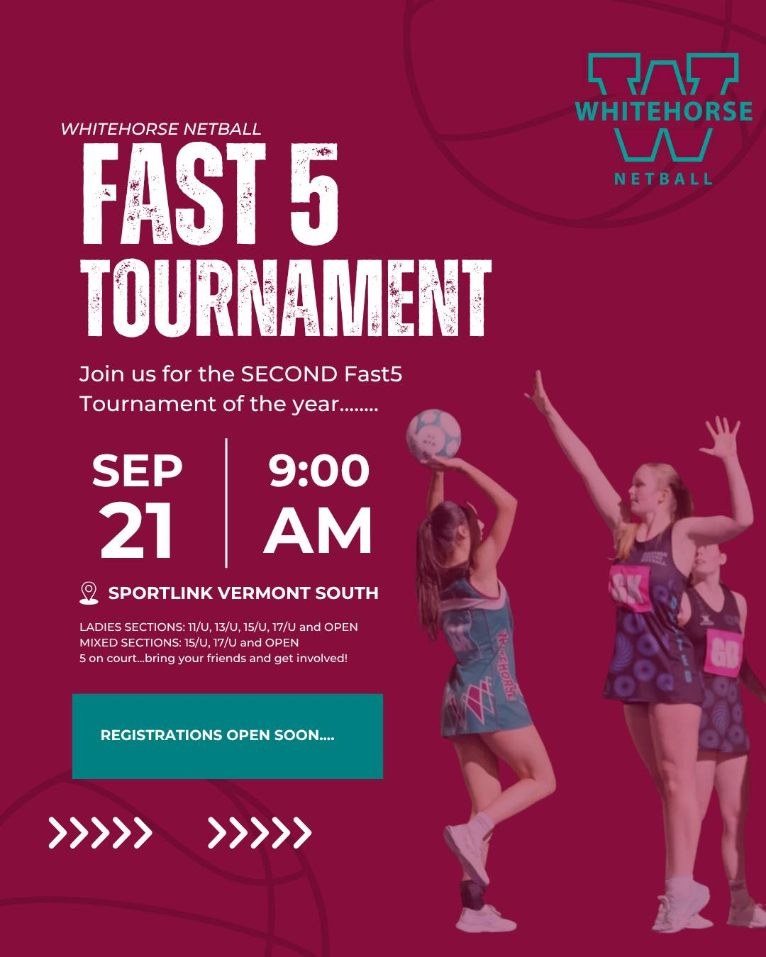
We understand and agree to the terms and conditions in registering a team to play in the Fast Five competition. We have read and understood all the rules for this Competition. I understand that if there is a lack of numbers in our age group, we may merge with another age group or with mixed. If there is an insufficient number of entries, the tournament may be cancelled. Games may be played inside or outdoor undercover. As the team contact, I also acknowledge that it is my responsibility to notify players of playing times and to ensure all players abide by our rules and regulations. We give permission for Whitehorse Netball Association to use photographs and video footage to promote on our website and social media. The age of the players in the team, is the age they will be on December 31st 2025. You will need to register in the age group of your oldest player.

TEAM NAME:

AGE GROUP: OPEN 17/U 15/U 13/U 11/U

COMPETITION: MIXED LADIES

CONTACT DETAILS:

ABILITY: VERY HIGH HIGH MEDIUM LOW VERY LOW

UNIFORM COLOURS:

BIB COLOURS:

COMMENT/QUESTIONS:

